OS Concept:Process Management

By Rathod Raja V.

1. What is Process ? Explain Process Layout.
Ans:
1. Process is nothing but the program in execution.
2. A process is more than the program code, which is sometimes known as the text section.
3. Process layout:

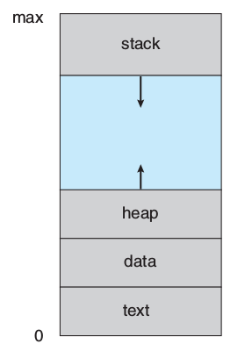

4. Stack segment contain loacl variable i.e. temporary data, heap segment contain memory that is dynamically allocated, data segment which contain global variable and text segment which contain program code.

2. What is process state ? Explain Process Control Block.
Ans:
1. As a process executes, it changes state.
2. There are ideally 5 process steps:
1. New: The process is being created.
2. Running: Instructions are being executed.
3. Waiting: The process is waiting for some event to occur (such as an I/O
completion or reception of a signal).
4. Ready: The process is waiting to be assigned to a processor.
5. Terminated: The process has finished execution.
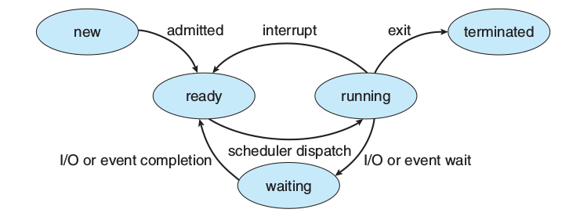
Fig. Process State

3. Each process is represented in the operating system by a process control block ( PCB )—also called a task control block.
4. Process state. The state may be new, ready, running, waiting, halted, and so on.
5. Program counter. The counter indicates the address of the next instruction to be executed for this process.
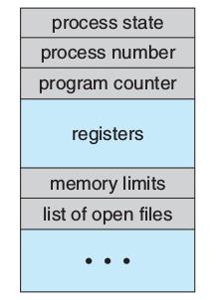

Fig. Process Control Block
6. I/O status information. This information includes the list of I/O devices allocated to the process, a list of open files, and so on.

3. What is Schedular ?
Ans:
1.Schedulers in Operating System are the process which decides which task and process should be accessed and run at what time by the system resources.

4. Explain Process Scheduling Algorithm.
Ans:
1. When multiple process executing at the same time then CPU has to decide which process has to execute first.
2. There are four scheduling algorithm:
1. First-Come First-Serve [FCFS]
2. Shortest Job First [SJF]
3. Priority Scheduling
4. Round Robin
3. In FCFS which process is coming first that will execute first.
4. In SJF which process require less time to execute that process will execute first.
5. In priority scheduling , execution of process will be according to priority.
6. In Round-Robin algorithm each process has a slice of time to execute.

5. What is Context switch ?
Ans:
1. In computing, a context switch is the process of storing and restoring the state (more specifically, the execution context) of a process or thread so that execution can be resumed from the same point at a later time.
2. Switching the CPU to another process requires performing a state save of the current process and a state restore of a different process. This task is known as a context switch.

6. Explain Interprocess Communication Mechanism.
Ans:
1. There are total 4 IPC
1. Message Queue
2. Shared Memory
3. Pipe
4. FIFO
5. Semaphore
1. In message queue the process memory allocation in is kernel space. So protection is there, but the execution speed is slow.
2. In shared memory the process memory allocation is user space, so the speed of execution is very fast but no protection is there.
3. Pipe is related process, i.e. only related process can communicate with each other. Only half duplex communication is possible. It is created by using pipe() system call.
4. FIFO is also called as named pipe, it is created by using mknode() of fifo system call.
5. Semaphore is used for synchronization between the processes.

